Is there anything you would be prepared to stand up and fight for? Would you be prepared to live on top of an abandoned bus station? In freezing temperatures? In a caravan? Protestors from Derby Friends of the Earth certainly would.

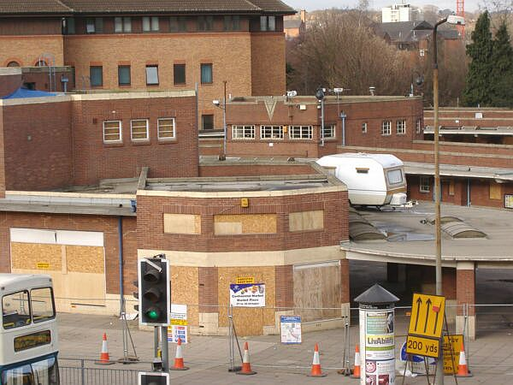

Has the dream of luxury accommodation at Derby Bus Station finally become a reality?

Several of their members have been camped out on top of Derby Bus Station – which is currently closed – since October 2005 in a bid to save the windy structure from demolition and to prevent the commencement of building work on the Riverlights project. Riverlights aims to bring a brand new sparkling bus station and leisure complex to the site, which backs onto the geologically important Riverside Gardens.

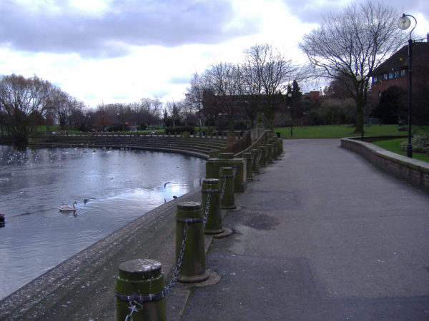

This is what the protestors are worried about – saving Derby Riverside Gardens.

The protest, which is led by veteran campaigner Dorothy Skrytek, has recently been buoyed by the mysterious addition of a small caravan which is perching precariously on top of the 30 ft high roof of the bus station. The caravan was donated by masked well wishers, who had the benefit of a crane to help them in their humanitarian mission. Derbyshire police have refused to facilitate the removal of the caravan – which undoubtedly adds a delicious touch of the absurd to the protest – because it is "not causing an obstruction".

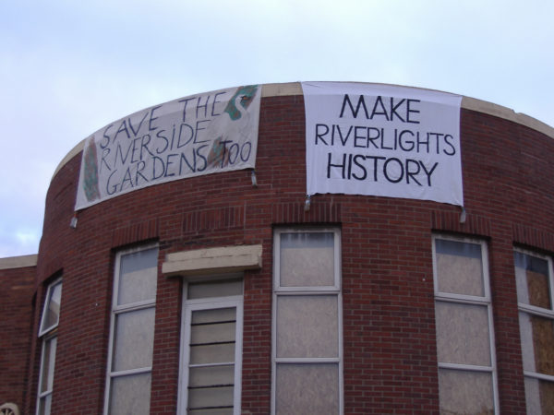

The protestors set out their stall.

Opinion in the fine and usually quite normal city of Derby has been decidedly split by the antics of Ms. Skrytek and her fellow protestors, with many – who are concerned about the introduction of a large entertainment complex and the noise and pollution it could cause – egging them on, while equally many are against the protest and argue that in their opinion the decrepit and unsanitary former bus station – which was designed by Charles Aslin to be useful to Derby bus passengers in the 1930s – is long overdue for knocking down.

Time will tell whether the campaigners will win out or not. Meanwhile, the saga goes on and grows ever more bizarre as weeks pass and winter gives way to spring. We await with wonder the next twist in this eccentric and undoubtedly great British story of pluck. A word of warning for the protestors though: in the story of David versus Goliath, David had only a sling and five smooth stones to defeat his foe. The introduction of the caravan to the bus station roof does, it can be argued, bring a no doubt welcome touch of luxury to the protest. But does it also, in fact, undermine the seriousness of the activists' campaign? After all, it's far easier to protest from the comfort of a caravan (albeit one which is rocking gently in the unkind winds that Derby is prone to) than from an exposed and forlorn rooftop.

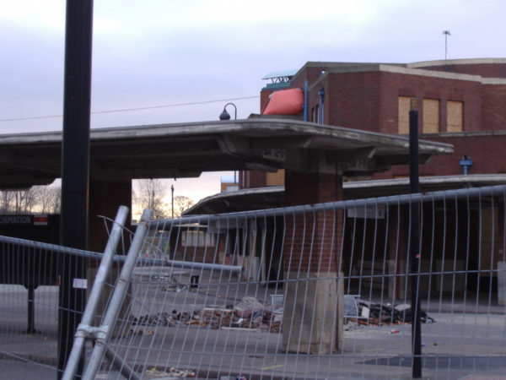

Derby Bus Station is currently closed and awaiting redevelopment.

Your task is to write 1000 words describing a cause that YOU would be willing to stand up and fight for.

