Now available to order from your local bookshop –

English Banana.com’s

big grammar book

by Matt Purland
Where’s your grammar, Jeff?
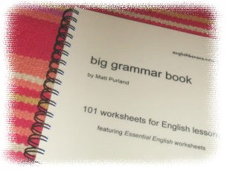
At home, Miss, watching the telly!

101 worksheets to practise grammar skills

Do you need to brush up your grammar? Help is at hand, with our brand new collection of photocopiable worksheets for ESOL and English students at Key Stages 3 and 4, taken from the popular English Banana.com website. The worksheets are easy to use and cover a wide range of grammar topics, from articles to conditionals, to question forms and compound nouns.

This handy collection comes complete with answers and notes for using the worksheets, so you can study at home – plus, the price includes full photocopying rights.

The big grammar book is published by English Banana.com and is available to buy now for only £29.95.

Order at your local bookshop, quoting: ISBN 0-9546985-0-9

or visit us online at www.englishbanana.com

