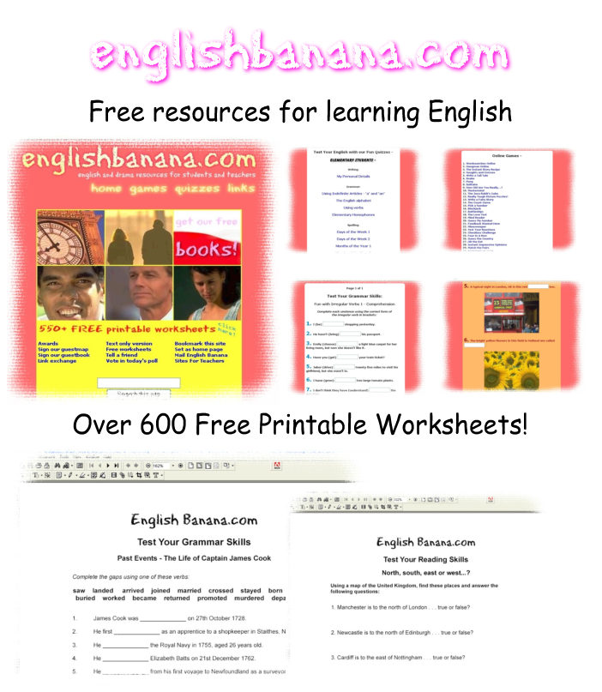

English Banana.com is a fun website for students and teachers of English and Drama. We have been providing quality free resources online since December 2002 and currently have over 600 worksheets for you to download and photocopy for use in class or at home; all absolutely free! We also provide online quizzes and fun games which are all geared towards improving English language skills, from Entry Level 1 to Level 2.

Visit us online at www.englishbanana.com now and check out our resources for yourself!

