Complete the gaps to find the titles of 15 popular Christmas carols:



Hark! The _______________ Angels Sing

Ding! Dong! _______________ on High

Away in a _______________

Silent Night, _______________ Night

God Rest Ye _______________ Gentlemen

O Come All Ye _______________

We Three _______________ of Orient Are

While Shepherds Watched Their _______________ by Night

O _______________ Town of Bethlehem

Good King _______________ Looked Out

The Holly and the _______________

Once in _______________ David's City

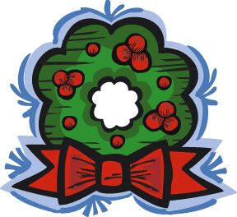
In the Bleak _______________

The First Nowell the _______________ Did Say

We Wish You a _______________ Christmas

Answers:

Hark! The Herald Angels Sing

Ding! Dong! Merrily on High

Away in a Manger

Silent Night, Holy Night

God Rest Ye Merry Gentlemen

O Come All Ye Faithful

We Three Kings of Orient Are

While Shepherds Watched Their Flocks by Night

O Little Town of Bethlehem

Good King Wenceslas Looked Out

The Holly and the Ivy

Once in Royal David's City

In the Bleak Midwinter

The First Nowell the Angel Did Say

We Wish You a Merry Christmas

