Have you wrapped up all your presents and put the last piece of tinsel on your tree? If you've finished putting up your Christmas decorations and written to Santa Claus (or Father Christmas – same difference!) why not put your feet up, have a mince pie or two, and try our fun Christmas quiz?

Do you know the famous Christmas song called The Twelve Days of Christmas? You do? That’s great! But can you remember what was sent and when?

maids a-milking geese a-laying pipers piping
calling birds ladies dancing swans a-swimming
drummers drumming gold rings lords a-leaping French hens partridge in a pear tree turtle doves

On the first day of Christmas my true love sent to me a… _____________________

On the second day of Christmas my true love sent to me two… _____________________

On the third day of Christmas my true love sent to me three… _____________________

On the fourth day of Christmas my true love sent to me four… _____________________

On the fifth day of Christmas my true love sent to me five… _____________________

On the sixth day of Christmas my true love sent to me six… _____________________

On the seventh day of Christmas my true love sent to me seven… ____________________

On the eighth day of Christmas my true love sent to me eight… _____________________
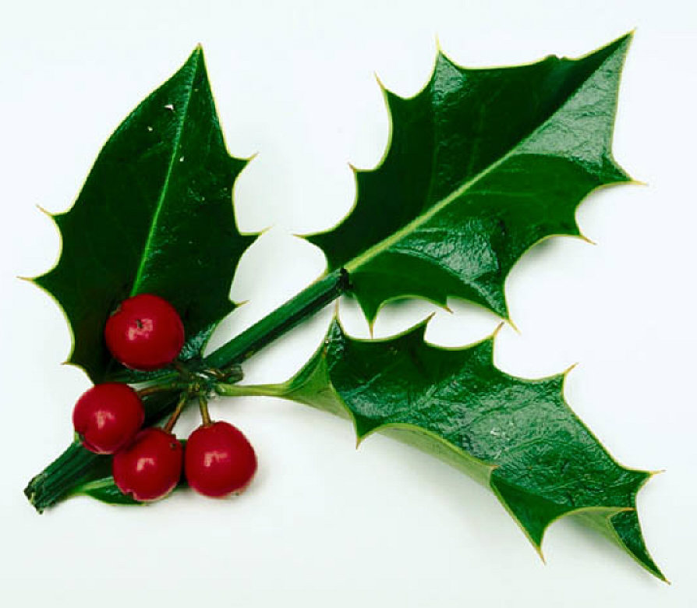
On the ninth day of Christmas my true love sent to me nine… _____________________

On the tenth day of Christmas my true love sent to me ten… _____________________

On the eleventh day of Christmas my true love sent to me eleven… ___________________

On the twelfth day of Christmas my true love sent to me twelve… _____________________

Answers:

On the first day of Christmas my true love sent to me a partridge in a pear tree.

On the second day of Christmas my true love sent to me two turtle doves.

On the third day of Christmas my true love sent to me three French hens.

On the fourth day of Christmas my true love sent to me four calling birds.

On the fifth day of Christmas my true love sent to me five gold rings.

On the sixth day of Christmas my true love sent to me six geese a-laying.

On the seventh day of Christmas my true love sent to me seven swans a-swimming.

On the eighth day of Christmas my true love sent to me eight maids a-milking.

On the ninth day of Christmas my true love sent to me nine ladies dancing.

On the tenth day of Christmas my true love sent to me ten lords a-leaping.

On the eleventh day of Christmas my true love sent to me eleven pipers piping.

On the twelfth day of Christmas my true love sent to me twelve drummers drumming.

