Join our
English class!

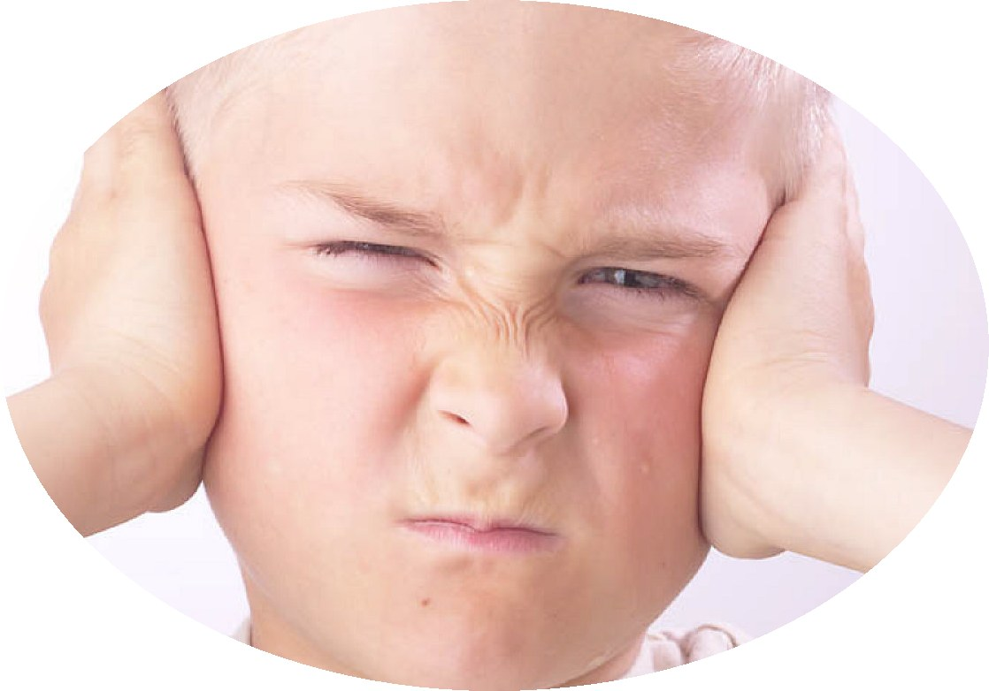

It’s more fun than babysitting!

English Banana.com

School

Place: ____________________________________

Time: ____________________________________

Contact: ____________________________________

