englishbanana.com’s

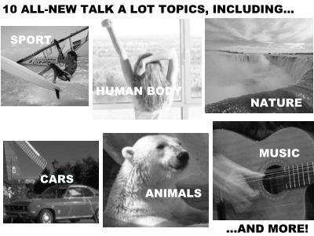

Talk a Lot
Spoken English Course

by Matt Purland

A Great New Way to Learn Spoken English

Elementary Book 2

