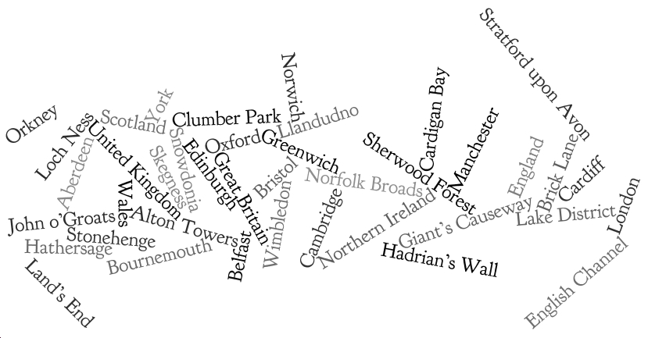

------------------------------------------------------------------------------------------------------------------------

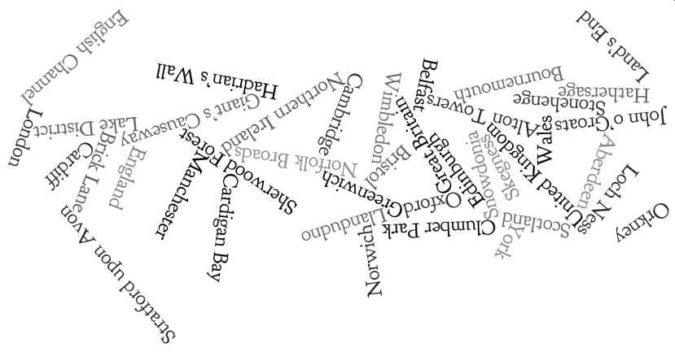

Images reproduced by kind permission of: http://www.wordle.net/

