Read the following sentences. Look at the words that have been highlighted by the spell-checker. Write the correct spelling underneath each highlighted word:

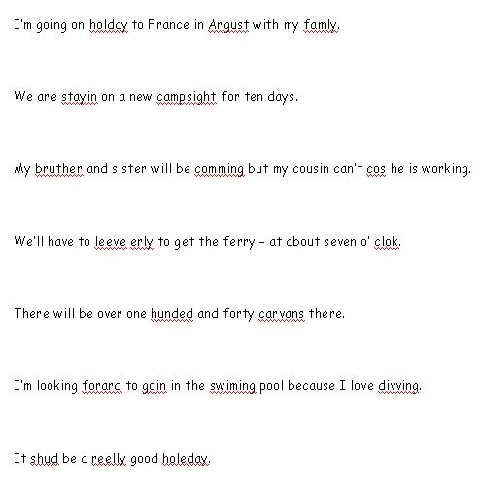

Answers:

holiday
August
family

staying
campsite

brother
coming
because

leave
early
o’clock

hundred
caravans

forward
going
swimming
diving

should
really
holiday

