Read the shopping list. Look at the words that have been highlighted by the spell-checker. Write the correct spelling underneath each highlighted word:

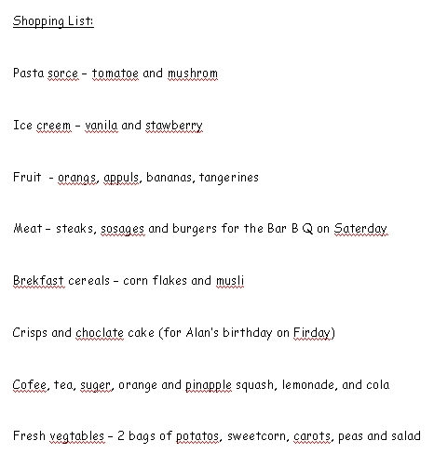

Answers:

sauce, tomato, mushroom

ice cream, vanilla, strawberry

oranges, apples

sausages, Saturday

breakfast, muesli

chocolate, Friday

coffee, sugar, pineapple squash

vegetables, potatoes, carrots

