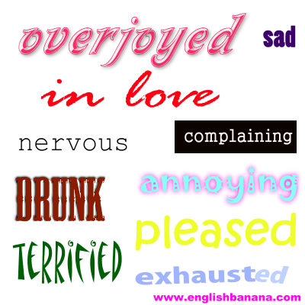

Match the adjectives above with the sentences containing English idioms of mood/emotion
(in bold):

- When I received the concert tickets for Muse I was on cloud nine!

- When my sister opened her birthday card and a cheque fell out she was tickled pink.

- When my brother returned home from the pub late last night I could see that he was pie-eyed.

- When I was waiting to go on stage to perform in front of the whole school I had butterflies in my stomach.

- When I finished my twelve hour shift at the supermarket I was completely zonked out.

- When Alan Forrester looked me in the eye at registration this morning I went weak at the knees.

- When my brother kept playing the same Rihanna song over and over again at full volume I told him, “You're driving me up the wall!”

- When I went on the Big One rollercoaster at Blackpool Pleasure Beach my heart was in my mouth.

- When my brother wouldn't stop going on about problems with his love life I told him not to be such a moaning Minnie.

- When my dad came home from work and just slumped in his armchair without saying a word, I asked him, “Why the long face?”

Answers:

1. overjoyed
2. pleased
3. drunk
4. nervous
5. exhausted
6. in love
7. annoying
8. terrified
9. complaining
10. sad

