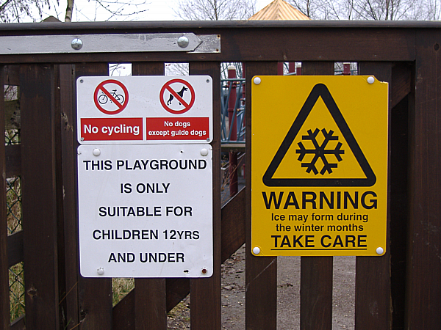

This picture was taken at Carsington Water reservoir in Derbyshire. Look at the questions below and write “true”, “false”, or “we don’t know” next to each one:

- The signs are on a gate at a children’s playground.

- The playground is closed.

- Children aged 12½ years old can use the playground.

- People can ride their bicycles in the playground.

- Dogs are not allowed in the playground, apart from guide dogs.

- It is possible to buy ice creams in the playground.

- The playground is suitable for young children.

- The warning sign shows a picture of an icicle.

- There is a lot of fun equipment for children to play with inside the playground.

- It is winter in this picture.

Answers:

- True.

- We don’t know.

- True.

- False.

- True.

- We don’t know.

- True.

- False. It is a picture of a snowflake.

- We don’t know.

- We don’t know.

