- Put the following times in the correct order, starting with the earliest in the morning.
- Write the times in words, and say whether it is am or pm, e.g.:

21:16 = sixteen minutes past nine pm

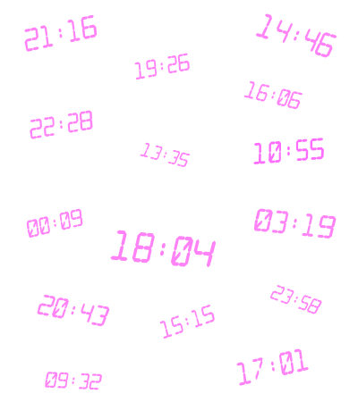

These are suggested answers only.

For example, learners could write 15:15 either: three fifteen pm, fifteen minutes past three pm, or quarter past three pm.

- 00:09 twelve oh nine am
- 03:19 three nineteen am
- 09:32 nine thirty two am
- 10:55 ten fifty five am
- 13:35 one thirty five pm
- 14:46 two forty six pm
- 15:15 three fifteen pm
- 16:06 four oh six pm
- 17:01 five oh one pm
- 18:04 six oh four pm
- 19:26 seven twenty six pm
- 20:43 eight forty three pm
- 21:16 nine sixteen pm
- 22:28 ten twenty eight pm
- 23:58 eleven fifty eight pm

